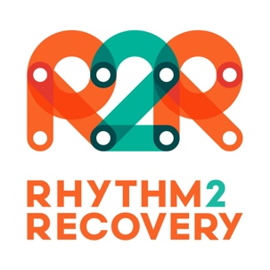

Permission to capture and use Photos or Video Footage as part of
a R2R Social & Emotional
Development Program

Our school / Service is running a social and emotional development program, based on the Rhythm2Recovery model of experiential music and cognitive reflection. This program will involve participants playing rhythmic music (drums and percussion) and discussing relevant themes that facilitate social and emotional awareness and education.

We are seeking your permission to take photos or video for promotional purposes during this course. These photos would be used to promote our school/service and may appear in our publications, or on our web site or social media pages.

If you are happy for your image or that of your child (where relevant) to be captured and used in this manner please sign the following form.

I give permission for my image or that of my child to be used for promotional purposes by the school or service below, and understand the different uses that may be made of these images.

program being delivered by ………………………………………………………………………………………………
(name of school or service)

Name of participant ……………………………………………………………………………………………………………

Name of parent/guardian ……………………………………………………………………………………………………
(where relevant)

Signature of participant or parent/guardian ……………………………………………………………………….

Date ………………………………………………………………….

