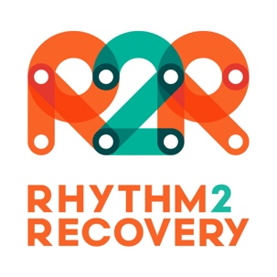

Permission to Participate
in R2R Social & Emotional Development Program

Our school / Service is running a social and emotional development program, based on the Rhythm2Recovery model of experiential music and cognitive reflection. This program will involve participants playing rhythmic music (drums and percussion) and discussing relevant themes that facilitate social and emotional awareness and education.

This format has been evaluated through a number of research studies and is strongly evidence based. Research has validated the use of this method to support the development of a wide range of social and emotional skills that promote general wellbeing and improve relationships.

If you are happy for your child to participate in this program please sign the following form.

I give permission for my child to participate in the social and emotional development

program being delivered at ………………………………………………………………………………………………
(name of school or service)

Name of child/student ……………………………………………………………………………………………………….

Name of parent/guardian ……………………………………………………………………………………………………

Signature of parent/guardian …………………………………………………………………………………………….

Date ………………………………………………………………….

